CS502 – Midterm Spring 2013 (26 May-05 June)

How would you modify QUICKSORT to sort into non-increasing order?
Answer: - Click here for detail
To make QUICKSORT sort in non-increasing order we must modify PARTITION.

Q- We can avoid unnecessary repetitions for recursive calls?
Answer: - (Page 74)
We can avoid these unnecessary repetitions by writing down the results of recursive calls and looking them up again if we need them later. This process is called memoization.

Q-Write a pseudo code Fibonacci With memorization? -- (3)
Answer: - (Page 74)
MEMOFIB(n)
1 if (n < 2)
2 then return n
3 if (F[n] is undefined)
4 then F[n] MEMOFIB(n − 1) + MEMOFIB(n − 2)
5 return F[n]

Spelling correction in edit distance? 3 marks
Answer: - (Page 76)
If a text contains a word that is not in the dictionary, a ‘close’ word, i.e. one with a small edit distance, may be suggested as a correction. Most word processing applications, such as Microsoft Word, have spelling checking and correction facility. When Word, for example, finds an incorrectly spelled word, it makes suggestions of possible replacements.

Bubble sort?
Answer: - (Page 39)
Scan the array. Whenever two consecutive items are found that are out of order, swap them. Repeat until all consecutive items are in order.

What is the worst case running time for the Quick sort? What simple change is
required in the algorithm to preserve its linear expected running time and makes it
worst case time Θ(n log n)
Answer: - (Page 49)
Worst case running time is O (n).
The simple change which can change the running time of the edit distance algorithm is the number of entries n2.

CS502 – Midterm Spring 2013 (26 May-05 June)

QUICK, HEAP, COUNTING, MERG KA TABLE KA JIS ME STABLE OR IN-PLACE BTANEY THE 5 MARKS
Answer: Page 54
IN Place | Stable
Selection Sort
Quick Sort
Heap sort
Bubble sort | Bubble sort
Insertion Sort | Insertion Sort
 | Merge sort
 | Counting sort

ADIT DISTANCE KI 3 APPLICATION K NAME BTANEY THE 3 MARKS
Answer: - (Page 76)
Spelling Correction
Plagiarism Detection
Speech Recognition

MEMOIZATION KI DIFINATION THI 2 MARKS
Answer: - Click here for detail
Memoization is an optimization technique used primarily to speed up computer programs by having function calls avoid repeating the calculation of results for previously processed inputs

WORS CASE OR AVERAGE CASE DEFINE KRNE THE 2 MARKS
Answer: - (Page 13)
Worst-case time is the maximum running time over all (legal) inputs of size n
Average-case time is the average running time over all inputs of size n.

CS502 – Midterm Spring 2013 (26 May-05 June)

Write Essential constraint of Counting sort.
Answer:
Essential constraint for the counting sort is that numbers to be sorted must be small integers i.e., 1…..k where k is small.

What are total numbers of entries in matrix for edit distance?
Answer: - (Page 84)
There are O(n2) entries in the matrix. Each entry E(i, j) takes O(1) time to compute. The total running time is O(n2).

WHAT IS the necessary assumption for average case analysis quick sort?
Answer: - (Page 50)
Average case depends on some assumption about the distribution of inputs. However, in the case of quicksort, the analysis does not depend on the distribution of input at all. It only depends upon the random choices of pivots that the algorithm makes

Suggest & describe modifications of the implementation of "Quick sort" that will improve its performance?
Answer: - (Page 76)

CS502 – Midterm Spring 2013 (26 May-05 June)

Q1 : How we Heapify?
Answer:
If an element in the Heap is not at its proper place means it is violating the Heap Order, the Heapify procedure is used to fix it and place it at its proper position. In Heapify, we recursively swap the element with its larger one child and stop at a stage when this element is larger than both of its children or it becomes the leaf node.

Q2 : Describe Heap sort algorithm?
Answer: - (Page 43)
HEAPIFY( array A, int i, int m)
1 l LEFT(i)
2 r RIGHT(i)
3 max i
4 if (l _ m)and(A[l] > A[max])
5 then max l
6 if (r _ m)and(A[r] > A[max])
7 then max r
8 if (max 6= i)
9 then SWAP(A[i],A[max])
10 HEAPIFY(A,max,m)

Q3 : How many elements are in matrix of edit distance?
Answer: Rep

Q6 : suggest and describe one modification of implementing quick sort? 5marks

CS502 – Midterm Spring 2013 (26 May-05 June)

Edit Distance in Speech Recognition
Answer: - (Page 77)
Speech Recognition
Algorithms similar to those for the edit-distance problem are used in some speech recognition systems. Find a close match between a new utterance and one in a library of classified utterances.

What is sorting? Describe slow running sorting algorithms. 5 marks
Answer: - (Page 39)
Sorting is any process of arranging items in some sequence and/or in different sets, and accordingly,
There are a number of well-known slow O(n2) sorting algorithms. These include the following:
Bubble sort: Scan the array. Whenever two consecutive items are found that are out of order, swap them. Repeat until all consecutive items are in order.
Insertion sort: Assume that A[1..i − 1] have already been sorted. Insert A[i] into its proper position in this sub array. Create this position by shifting all larger elements to the right.
Selection sort: Assume that A[1..i − 1] contain the i − 1 smallest elements in sorted order. Find the smallest element in A[i..n] Swap it with A[i]. These algorithms are easy to implement. But they run in _(n2) time in the worst case

Catalan Numbers and their formula 3 marks
Answer: - (Page 85)
Catalan numbers are related the number of different binary trees on n nodes. Catalan number is given by the formula:
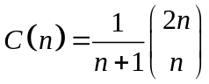

CS502 – Midterm Spring 2013 (26 May-05 June)

Q1.Heap Sort , Counting Sort , Quick Sort ,Merge Sort , in ,table ,And required to tell , which is inplace Algorithm and stable ? Marks 5
Answer: rep

Q2 . Suggest that how can make better improvement in Quick Sort algorithm .Marks 5
Answer: - (Page 54)
The best we have seen so far is O(n log n) algorithms for sorting. Is it possible to do better than O(n log n)? If a sorting algorithm is solely based on comparison of keys in the array then it is impossible to sort more efficiently than (n log n) time.

Q3. Consider three numbers with comparison based sortig algorithim and write possible combination in a1,a2,a3 .Marks 3
Answer: - (Page 85)
Consider sorting three numbers a1, a2, a3. There are 3! = 6 possible combinations:
(a1, a2, a3), (a1, a3, a2), (a3, a2, a1)
(a3, a1, a2), (a2, a1, a3), (a2, a3, a1)

Q4. What is better aproach of multiplication rather than straight form of Multiplication . Named that . Marks 3
Answer: - (Page 54)
Chain Matrix Multiplication-Dynamic Programming Formulation

Q6.worst case and average case algorithm of Quick Sort .Marks 2
Answer: - (Page 50)
Answer: Worst case = O(n2)
Average Case = O(n log n)

CS502 – Midterm Spring 2013 (26 May-05 June)

1.worst case of bucket algorithm
Answer: - O(n)

Catalan Numbers and their formula 3 marks
Answer: rep

speech reorganization.2
Answer: rep

Worst and average case of quick sort algorithm.2 marks
Answer: rep

CS502 – Midterm Spring 2013 (26 May-05 June)

Radix sort table ? 5 marks
Answer:
Radix sort:
In linear time sorting, counting sort is used for the numbers in the range 1 to k where k is small and it is based on determining the rank of each number in final sorted array. But it is useful only for small integers i.e., 1 ….k where k is small. But if k were very large, then the size of the rank array formed would also be very large which is not efficient. So solution for such cases is the Radix sort which works by sorting one digit at a time.
Example:
841 84[1] 8[4]1 [1]85
185 è 37[3] è 3[7]3 è [3]73
373 18[5] 1[8]5 [8]41

CS502 – Midterm Spring 2013 (26 May-05 June)

- What are the worst and average run times of quick sort? (2 marks)
Answer: rep

- What are total numbers of entries in matrix for edit distance? (2 marks)
Answer: rep

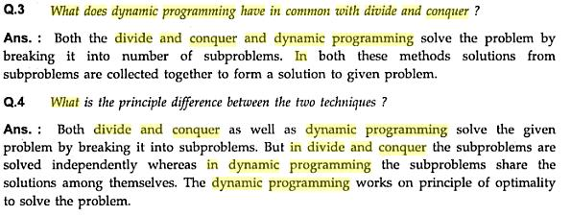

5. Show that the running time of quick sort when the array A contains distinct elements and sorted in decreasing order ? (5 marks)
Answer:
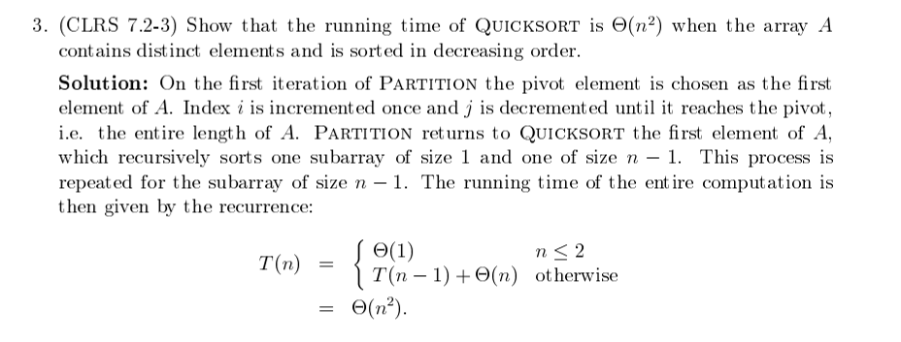
6. Illustrate how Radix Sort works on the following words: Show the result of first 2 passes only.
COW, DOW, SEA, RUG, ROW, MOB, BOX, TAB, BAR, EAR, TAR, DIG, BIG, TEA, NOW, FOX
Answer:
COW DOG SEA RUG ROW MOB BOX TAB BAR EAR TAR DIG BIG TEA NOW FOX
SEA TAB TEA BAR MOB EAR TAB TAR DOG SEA RUG TEA DIG DIG BIG BIG BAR MOB EAR DOG TAR COW COW ROW ROW NOW NOW BOX BOX FOX FOX RUG BAR BIG...

CS502 – Midterm Spring 2013 (26 May-05 June)

Q: define heap and heap oerder
A heap is a left-complete binary tree that conforms to the heap order.

Q:Average-case Analysis of Quicksort
Average case analysis of Quick sort: The running time of Quick sort depends on the selection of pivot q which is done randomly. For average case analysis of quick sort, average is computed over all possible random choices of the pivot index q. The average case running time for quick sort is ϴ (n log n).
Q:Worst case Analysis of Quick sort
Worst case analysis of Quick sort: For worst case we maximize over all possible values of q, means the selection of pivot q which gives the maximum (worst) time for sorting. The chances are that the pivot values q=1 (start) or n (end) or n/2 (middle) happen to give maximum time values. The worst case running time is O (n2).

CS502 – Midterm Spring 2013 (26 May-05 June)

In Random Access Machine, instructions are executed _________ Instructions are executed
Answer:- one-by-one (there is no parallelism). (Page 10)

Dynamic Programming algorithm:
Answer: - The genius of the algorithm is in the clever recursive formulation of the shortest path problem. (Page 162)

For the heap sort, access to nodes involves simple __ arithmetic ___ operations. (Page 40)

Comparison based sorting algorithm cannot run faster than __ Ω(n log n) __ (Page 46)

Fibonacci sequence was posted by __ Leonardo Pisano, ___ (Page 73)

